**Week 4 Project**

Nick Molliconi

Regis University

MSDS 670 Data Visualization

Mr. John Koenig

May 28, 2023

**Abstract**

The week four (4) project focused on the impact of Covid-19 pandemic on the airline industry, specifically the stock price of major passenger airline cariers. The dataset was obtained from kaggle.com, specifically from yfinace: (<https://pypi.org/project/yfinance/>). The data set included data from January 2018 thru March of 2023 from the S&P 500 Stock Exchange. This analysis focused on the sub-industry of passenger airlines and included the stock activity for American, Delta, Alaska, United and Southwest Airlines. The data columns included daily stock activity of open, close, high, low, stock split, dividends and volume. The visualizations and analysis focused on the close and volume columns. Additionally, the analysis focused on the question of which passenger airline had the worst performing stock during the pandemic.

The airline industry was signifignatly impacted by the COVID-19 pandemic to the point where international travel came to a standstill (Richter, 2021). The International Aviation Transportation Association (IATA) indicated that in 2020, global passinger traffic declined by 65.9% compared to 2019. Additionally, both international and domestic demand dropped by 75.6% and 48.8%, respectively in 2020 (Richter, 2021). The financial impact to airlines was devestating with such a signifigant decrease in passenger volumes. Revenues, growing expenses and stock prices were all impacted, but one passenger airline was more signifigantly impacted than any other. American Airlines, out of the five (5) airlines evaluated within this dataset, had the most negative impact on their respective stock price.

According to an article in Forbes, American Airlines stock price saw a signifigant decrease from 2018 to 2020. There were multiple reasons for this decrease, which include a decrease in sales, mostly due to the pandemic, a lower price to sale (P/S) ratio and a signifigant increase in share count (Forbes, 2022). Total revenue in 2018 was $45.8 billion and signifigantly decreased to $17.3 billion at the end of 2020, largley due to the pandemic. Additionally, the number of shares increased from 545 million in 2018 to 652 in 2022 (Forbes, 2022).

The visualization below is the initial analysis to begin to see which passenger airline had the highest yearly average decrease in closing stock price. As you can see, all of the five (5) passenger airlines within this dataset experienced a decrease in average price, especially in 2020, from 2019. From this visualization, it would seem that United Airlines had the biggest decrease, which holds true, but further analysis must be performed to see which airline had the largest decrease. Delta, Alaska and Southwest had similar price points from 2018-2023, so it is difficult to see substantial variation. American Airlines, priced below the other four (4) airlines also has a decrease.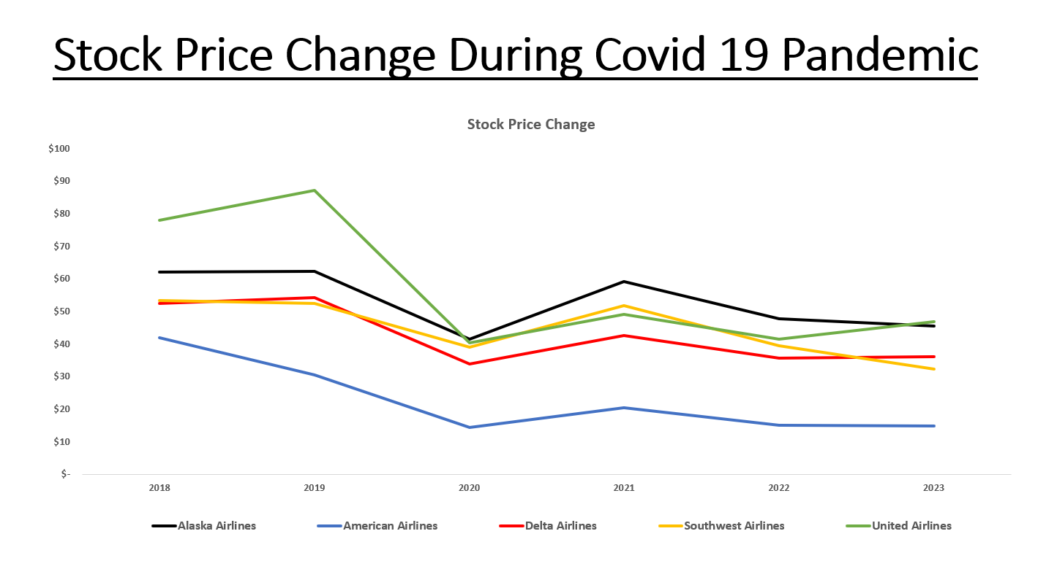

The next visualization analysis the percentage (%) change of the average year end price of 2022 compared to 2018. This analysis did not include 2023 since this analysis occurred in May of 2023. Highlighted in red, American Airlines had the most substantial negative variation in its average stock price from 2018 to 2022. As indicated by the visualization below, American Airlines saw a 63.9% decrease in average year-end stock price from 2018 to 2022. Where Alaska, Southwest, Delta and United saw a decrease value of 22.9%, 26.0%, 32.1% and 46.9%, respectivly.

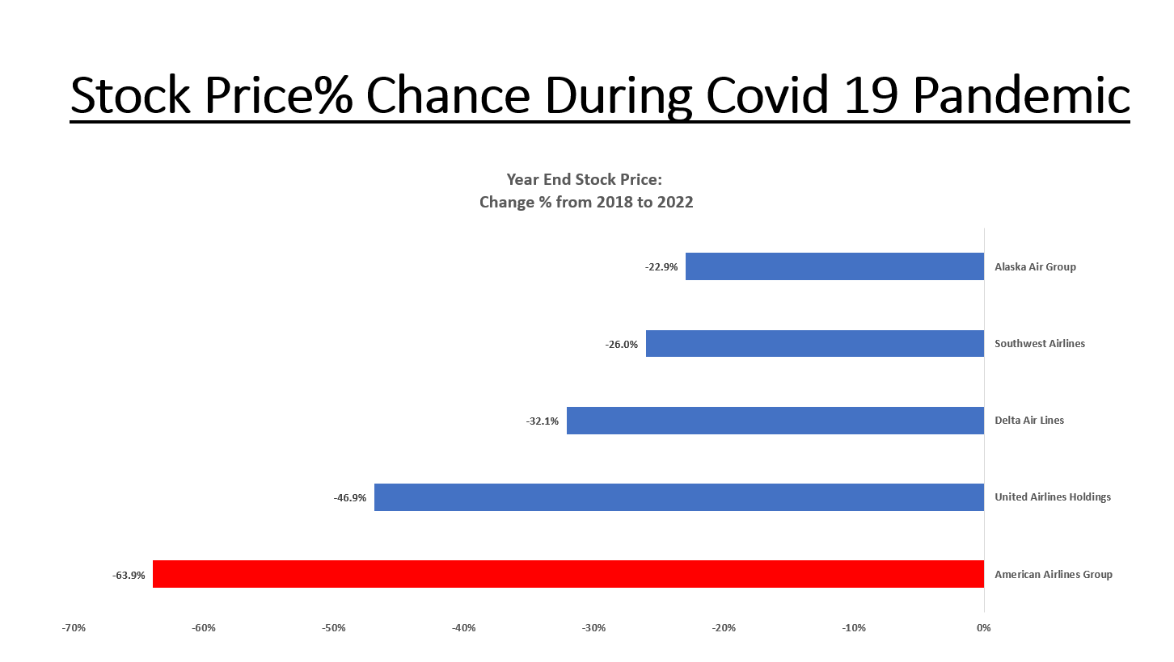

The next visualization is specifically focused on the performance of American Airlines avearge stock price during 2018 through 2022. The added datapoint is the volume of shares traded by day and this is a dual axis visualization to reflect that. It is interesting to see, during 2020, the highest volume trading occurred in June 2020 with over three (3) million shares traded with an average stock close of $13.07. The table also illustrates the % change for this month compared to the average of 2018. A staggering 2,066% change in average volume from 2018 to June 2020 and a decrease of 68.8% in share price.

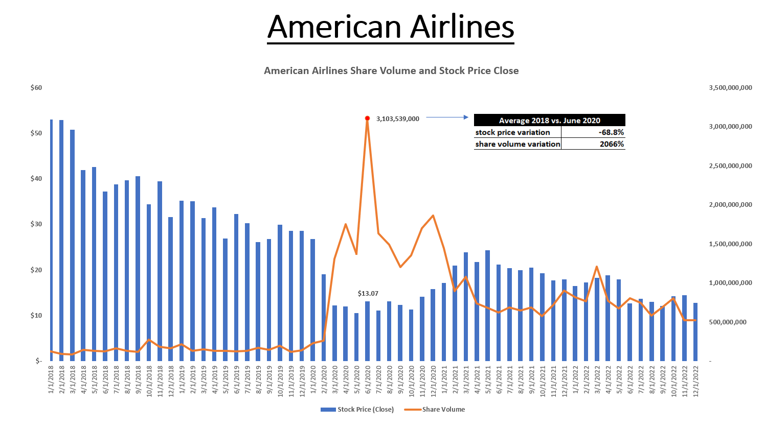

**Conclusion:**

The Covid-19 pandemic had a signifigant financial impact on the passenger airline industry with travel nearly ceasing to exist for a period of time. The five (5) passenger airlines, within this dataset from Kaggle, reflected this negative financial downturn. Out of the five (5) passenger airlines in this dataset, American Airlines had the most signifigant negative financial impact out of the five (5). Revenue for Ameican Airlines decreased by 62% from 2018 to 2020 a shift of over $27.2 billion (Forbes, 2022). Since 2020, American has been able to increase its total revenue to $40.7 billion in 2022, which is more inline with what they had earned prior to the outbreak of the pandemic (Forbes, 2022).

**References:**

Richter, Felix. (2021, February 18). Aviation industry suffers 'worst year in history' as COVID-19 grounds international travel. [www.weforum.org](http://www.weforum.org). Retrieved on May 13, 2023 from <https://www.weforum.org/agenda/2021/02/covid19-coronavirus-tourism-aviation-industry-decline/>.

Retrieved on May 13, 2023 from <https://www.cnn.com/2020/08/25/perspectives/airlines-pandemic-9-11/index.html>.

Chokshi, Niraj. (2022, January 20). American Airlines posts a $931 million loss as the industry struggles to recover. www.nytimes.com. Retrieved on May 21, 2023 from <https://www.nytimes.com/2022/01/20/business/american-airlines-earnings-4q-2021.html#:~:text=American%20Airlines%20posts%20a%20%24931%20million%20loss%20as,it%20hoped%20to%20turn%20a%20profit%20this%20year>.

Kuznetsov, Alexander. (2023, May 6). S&P 500 Companies Price Dynamics. [www.kaggle.com](http://www.kaggle.com). Retrieved on May 21, 2023 from <https://www.kaggle.com/datasets/alexanderkuznetsovow/s-and-p-500-companies-price-dynamics>.

Bouwer, Jaap, Krishman, Vik, Saxon, Steve, Trufft, Caroline. (2022, March 31). [www.mckinsey.com](http://www.mckinsey.com). Taking stock of the pandemic’s impact on global aviation. Retrieved on May 21, 2023 from <https://www.mckinsey.com/industries/travel-logistics-and-infrastructure/our-insights/taking-stock-of-the-pandemics-impact-on-global-aviation>.

n.a. (2022, July 29). Here’s Why American Airlines Stock Has Shed More Than 50% Since Late 2018. [www.forbes.com](http://www.forbes.com). Retrieved on May 21, 2023 from https://www.forbes.com/sites/greatspeculations/2022/07/29/heres-why-american-airlines-stock-has-shed-more-than-50-since-late-2018/?sh=139a129c5a31